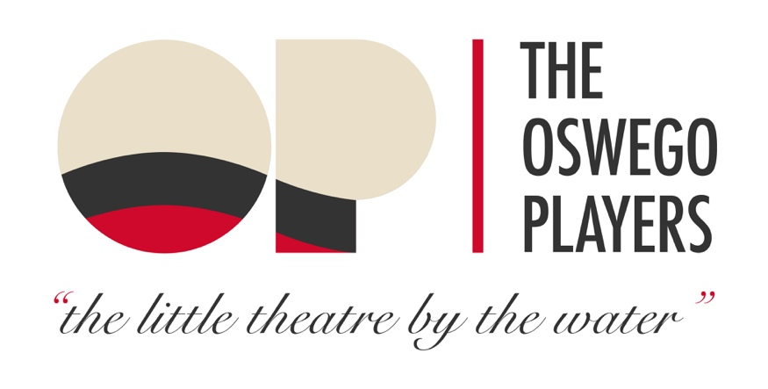
STAR LEVEL SPONSORSHIP 2022

BRONZE LEVEL $250+
1 Season Ticket
Bronze Star Placed on STAR SPONSORSHIP Wall in our Lobby
Name placed in all Playbills and on our website

SILVER LEVEL $500+
2 Season Tickets
Silver Star Placed on STAR SPONSORSHIP Wall in our Lobby
Name placed in all Playbills and on our website
Curtain Announcement opportunity at one show

GOLD LEVEL $1000+
4 Season Tickets
Gold Star Placed on STAR SPONSORSHIP Wall in our Lobby
Name and Logo Placed in all Playbills and on our website
Curtain Announcement opportunity at one show

PLATINUM LEVEL $2500+
1 ROW of Season Tickets (10)
Platinum Star Placed on STAR SPONSORSHIP Wall in our Lobby
Name and Logo placed on top or prominently in all Playbills
and on our website
Curtain Announcement opportunity at all shows
2 Press Opportunities

Check made payable to:

Oswego Players, Inc.
PO Box 183
Oswego, NY 13126

